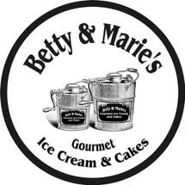

Dear Betty and Marie’s family,

In 2015, you graciously welcomed us into the Manassas Park community. It was our privilege to serve you the best homemade gourmet ice cream and cakes. We strived to provide five-star customer service. Along the way we felt your support as a community. From school fundraisers to community gatherings, we thoroughly enjoyed playing a present role in the local community. Our vision extended beyond the business aspect.
A few years later, we were awarded for being a promising new local business. Regardless of our optimism, we faced a number of obstacles, including changing our storefront location. We began to feel we were not satisfying our customers the way we had hoped to do. Now, it is with a heavy heart that we inform you of the permanent closure of Betty and Marie’s.
We will miss a lot of great people. We are going to miss all the employees, the VIP customers, their families, the teachers, the kids, the neighbors, the officers and firefighters. We cannot forget the candid conversations and jokes we shared. We never wanted to disappoint a single person that walked into the store. Through the good and the rough seasons, you all stuck with us.
As young entrepreneurs we’ve learned much. We know this is one step in the journey God has planned for us. We look forward to what the future holds. As of right now, I will be transitioning to take more ownership over my father's catering company in Springfield, VA. Thanks again for your continued support.

Sincerely,
Nathan Staggers

~Co-owner and Founder; Betty & Marie’s Gourmet Ice Cream

For questions/concerns or further business inquires, you can reach me at: nathan@bettyandmaries.com.

